Name:

Date:

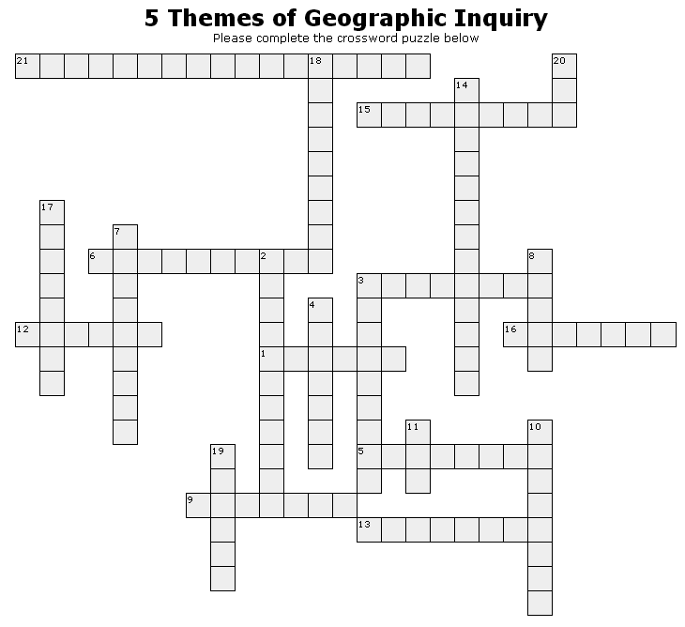

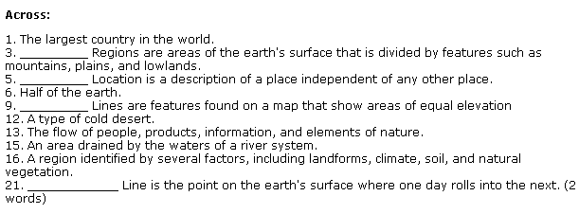
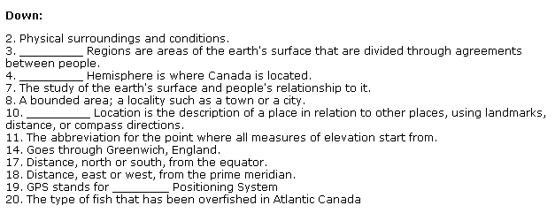

Word Bank:

Latitude  Longitude  International Date  Watershed  Cod  Prime Meridian  Russia  Canada  Hemisphere | Physical  Location  Environment  Western  Contour  Global  Earth  Southern  Absolute | Place  Tundra  Desert  Ecozone  Geography  Relative  Movement  MSL (Mean Sea Level)  Political

