Dear Parents / Guardians,

To meet the curriculum expectations we will discuss the following topics listed below in Health class.

Information discussed is geared to grade level, including basic facts and reassurance about your child's growth and development. Videos and Health Nurse visits are often included RE: puberty, human growth & development. The unit includes Q & A sessions and formal testing.

If you have any questions, please contact me and I will answer them as best I can.

**Topics to be covered include:**

* Male and female reproductive systems as they relate to fertilization.
* Facts / myths associated with menstruation, spermatogenesis & fertilization.
* Identifying methods of transmission and symptoms of STIs and prevention.
* Communication skills (Refusal skills, active listening) RE: relationships and situations.
* Abstinence as it applies to healthy sexuality.
* Identifying sources of support for sexuality.

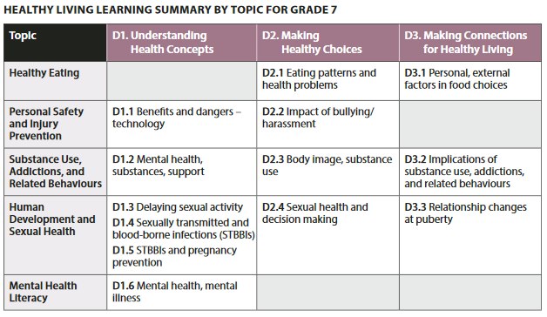

Specific curriculum expectations include:

D1. 3 explain the importance of having a shared understanding with a partner about the following: delaying sexual activity until they are older (e.g., choosing to abstain from any genital contact; choosing to abstain from vaginal or anal intercourse; choosing to abstain from oral-genital contact); the reasons for not engaging in sexual activity; the concept of consent, the legal age of consent, and how consent is communicated; and, in general, the need to communicate clearly with each other when making decisions about sexual activity in a healthy, loving relationship

D1.4 identify sexually transmitted and blood-borne infections (STBBIs), and describe their symptoms

D1. 5 identify ways of preventing STBBIs and/or unplanned pregnancy, such as delaying first intercourse and other sexual activities until a person is older and using condoms and other forms of protection consistently

D2.4 demonstrate an understanding of physical, emotional, social, and cognitive factors that need to be considered when making decisions related to sexual health (e.g., sexually transmitted and blood-borne infections [STBBIs], possible side effects of contraceptives, pregnancy, protective value of vaccinations, social labelling , gender identity, gender expression, sexual orientation, self-concept issues, relationships, love, respect, desire, pleasure, cultural teachings)

D3.3 explain how relationships with others (e.g., family, peers) and sexual health may be affected by the physical and emotional changes associated with puberty (e.g., effect of physical maturation and emotional changes on family relationships; effect of growing interest in intimate relationships on peer relationships; increased risk of STBBIs and/or pregnancy with onset of sexual activity)

<http://www.edu.gov.on.ca/eng/curriculum/elementary/healthcurr18.pdf>

<http://www.downwindkennels.com/me/SubjectLinks/health/main.html>

Sincerely,   
D. Fitch