**Myth vs. Fact** 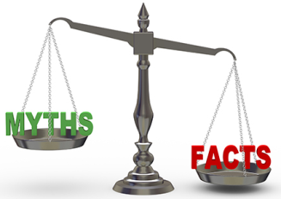

Circle all factual statements (true).

1. Fertilization takes place in the uterus.
2. You cannot go swimming if you have your period.
3. All girls have cramps when they get their period.
4. Males only have erections when they are thinking about sex.
5. Sperm have to be kept at a temperature that is lower than body temperature to survive.
6. Boys can tell when a girl has her period.
7. Smoking may affect the ability to achieve an erection.
8. Fertilization is the union of the sperm and the ovary.
9. You should bathe or shower every day after the start of puberty.
10. All females are more emotional during their period.
11. Males are born with immature sperm in their testes.
12. After puberty, a male continues to produce sperm throughout the rest of his life.
13. Fertilization can only occur right after intercourse.
14. Drinking alcohol and smoking has no effect on sperm.
15. Breast or penis size does not affect function.

**Myth vs. Fact – ANSWERS!**

All factual statements are in red. **(TRUE).**

1. Fertilization takes place in the uterus.
2. You cannot go swimming if you have your period.
3. All girls have cramps when they get their period.
4. Males only have erections when they are thinking about sex.
5. Sperm have to be kept at a temperature that is lower than body temperature to survive.
6. Boys can tell when a girl has her period.
7. Smoking may affect the ability to achieve an erection.
8. Fertilization is the union of the sperm and the ovary.
9. You should bathe or shower every day after the start of puberty.
10. All females are more emotional during their period.
11. Males are born with immature sperm in their testes.
12. After puberty, a male continues to produce sperm throughout the rest of his life.
13. Fertilization can only occur right after intercourse.
14. Drinking alcohol and smoking has no effect on sperm.
15. Breast or penis size does not affect function.