NUTRITION QUIZ / 25

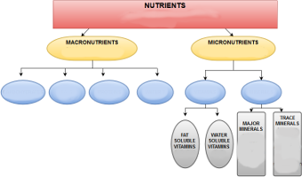

1. Define nutrients. (1 pt)

2. Define macro-nutrients. (2 pts)

3. Define micro-nutrients. (2 pts)

4. List the 6 nutrients. (6 pts)

5. List the micro-nutrients. (2 pts)

6. List 3 major minerals. (3 pts)

7. List 3 trace minerals. (3 pts)

8. What category did Mr. F put WATER in? Explain why it belongs there & why not. (2 pts)

9. Complete the FOOD CHOICES chart. (4 pts)


