EATING HEALTHY AND MAINTAINING AN IDEAL BODY WEIGHT
According to Health Canada, eating well and being active work together to help people maintain optimal health and an ideal bodyweight. In doing this people are able to reduce the risk of obesity, type 2 diabetes (type 1 is much different), heart disease, certain types of cancer and osteoporosis. Healthy eating also has many benefits such as:
- Better overall health

- Lower risk of disease
- A healthy body weight
- Feeling and looking better
- More energy
- Stronger muscles and bones
Some steps towards better health and a healthy body weight include:
- Eating the recommended amount and types of food each day.
- Limiting foods and beverages high in calories, fat, sugar or salt (sodium).
- Being active every day.
What are you doing to eat healthy and maintain an ideal body weight?
__________________________________________________________________________________________________________________________________________________________________________________________________________________________________________________________________________________________________________________________________________________________________________________________________________________________________________________________________________________________________________________________________________

NUTRITION LABELLING
Nutrition labelling became mandatory for all pre-packaged foods on December 12, 2007.
The Nutrition Facts table appears on food labels with a consistent look, making it easy to find and easy to read. The labelling regulations, introduced in 2003, also updated the requirements of over 40 nutrient-content claims and allowed five health claims on diet-health relationships to be used on food labels or in advertisements.
Together, the Nutrition Facts table, the nutrition claims and the ingredient list provide Canadians with more information to make informed food choices

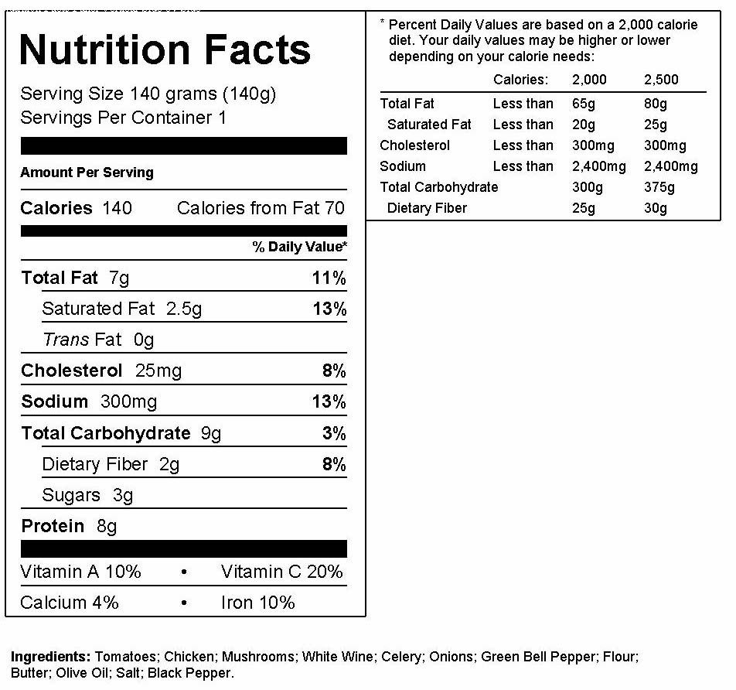

Name: Date:
 NUTRITION FACTS TABLE ANALYSIS
Choose 2 Nutrition Facts labels of FOOD (no drinks!) that you have consumed. Good & Bad Food – Include 2 original labels with this assignment. – no computer printouts!
Answer in full sentences with the help of a nutrition fact table. Give details. Express your thoughts on the nutrition info. discussed. What levels of fat/sodium/nutrients [vitamins/minerals], etc… is too low/acceptable/excessive?

  - What are the names of your food products?

  - Do you think your food products are healthy to eat?

  - How big is one serving size for each of your food products?

  - How much Fat is in your food products according to their tables? Discuss.

  - What are the Daily Values (%) of cholesterol in your products? Discuss.

  - Are there any Vitamins in your food products? If so, How much & what are they?

  - How many total Calories are in each of your food product’s servings? Discuss.

  - Is there any sugar (glucose) in your food products? (Check the ingredients) Discuss.

  - Is there any salt (sodium) in your food products? Discuss.

  - Overall, after analyzing your products would you eat them and still consider it to be healthy for you to eat? Why? – a paragraph response is appropriate (Min. 5 sentences.)

