YUCK! – A NY School Lunches Documentary 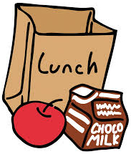

- Define:

Additives - ____________________________________________________________________________________________________________________________________________________________________________________________________________
Preservatives - ____________________________________________________________________________________________________________________________________________________________________________________________________________

Calories - ____________________________________________________________________________________________________________________________________________________________________________________________________________

2. What did you notice about the school lunches? _________________________________________________________________________________________________________________________________________________________________________________________________________________________________________________________________________________
- What advice do you have for the film maker? ____________________________________________________________________________________________________________________________________________________________________________________________________

- How do you think the principal of the school reacted after seeing this documentary? _________________________________________________________________________________________________________________________________________________________

- What is the main message of this indie film? ___________________________________________________________________________________________________________________________________________________
_________________________________________________

