SMOKING FOUR CORNERS 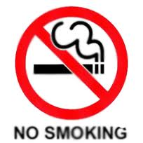

- Smokers should pay for their “dirty habits”. They should not be allowed to have children.

- The “Smoking Age” should be raised to 20 years old.

- Smoking should be outlawed in public spaces such as parks, restaurants, bus stops, etc…

- Adults should be fined by the police if they smoke in a car with a child.

- Smoking is a basic human right. Our government shouldn’t punish people.

- People who smoke should have to pay more taxes since they will use the hospitals more often.

- To reduce smoking related deaths, farmers in Canada need to be discouraged from growing tobacco crops.

- Nicotine is an addictive drug. It’s a good idea for employers to be more understanding to help their employees quit smoking.

- Boys have a harder time saying no to smokes than girls.

- Smokers pay millions of dollars in taxes each year. We need smokers to raise money to pay for infrastructure such as schools, police, hospitals, roads, army…

- Smokers would benefit from rationing. Buyers should be limited to a pack a day for their health.

- Cigarette production should be banned in Canada.

- It is not the public’s concern if individuals choose to smoke.

- Hollywood actors should not smoke in the movies since it influences kids.

