NAME: _________________________
What do you know about Canadian History?
DATE: _____________
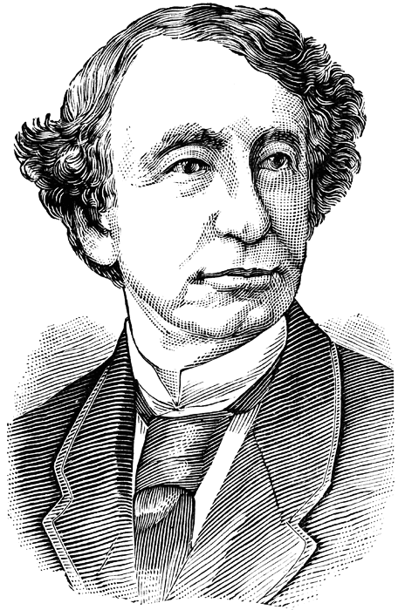 | Grade 8 History  Confederation, Development of Western Canada, and A Changing Society | 

- Who was the 1st Prime Minister of Canada?

  - Sir Wilfred Laurier
  - Lord Elgin
  - Sir John A. Macdonald
  - Stephen Harper

- What important event happened on July 1, 1867?

  - France took back North America
  - A new country called “Canada” was born
  - Nothing important really
  - World War I started

- The name of the act that made Canada independent was called:

  - the British North America Act (BNA Act)
  - the Canadian Initiative
  - the ‘High Five’
  - None of the above

- The Hudson Bay Company use to own Rupert’s Land.

  - True
  - False

- The Canadian term of ‘Confederation’ means:

  - The dismantling of a nation
  - Ask Farmer Brown
  - The turning of political control over Canada to England
  - The time when 4 provinces united to form the country of Canada

- The creation of the Canadian Pacific Railway opened up the West Coast and connected British Columbia to the rest of Canada.

  - True
  - False

- People migrated to Canada because they were forced to, and not because of the land.

  - True
  - False

- The western end of the Canadian Pacific Railway was built by:

  - Irish Immigrants
  - English loyalists
  - Sophisticated machines
  - Chinese Labourers

- Newfoundland was:

  - One of the last provinces to join Confederation
  - Not important to confederation
  - A place where Farmer Brown would send his cows
  - One of the first provinces to join Confederation

- The ‘Red River Rebellion’ happened in Winnipeg, Manitoba.

  - True
  - False

