**INTEGERS – ANSWERS**

Question 1: Adding opposite integers together demonstrates the...



1. Pythagorean theorem
2. Cancelling conundrum
3. Zero principle
4. Principle of negatives

Question 2: Which of the following are opposite integers?



1. (-10) and 12
2. 6 and (-10)
3. 3 and (-5)
4. (-10) and 10

Question 3: A negative number is any number that is...



1. equal to zero.
2. greater than zero.
3. less than zero.
4. less than 5.

Question 4: A negative number multiplied by a negative number will produce a...



1. positive number.
2. negative number.
3. a positive or negative number, depending on which number is bigger.
4. a positive or negative number, depending on which number is smaller.

Question 5: The temperature this afternoon was 4⁰C, then the temperature dropped by 10⁰C. The temperature is now...



1. 14⁰C
2. -14⁰C
3. 6⁰C
4. -6⁰C

Question 6: Maggie owes the candy store $35. Her 5 friends agree to pay off her debt. How much will each friend pay?



1. $5
2. $6
3. $7
4. $8

Question 7: John has $25 in his bank account, then buys $35 of candy. What's his new balance?



1. -$10
2. $10
3. $35
4. $-60

Question 8: Which of these equals 10?



1. (-10) + 10
2. 5 - (-5)
3. -5 - (-5)
4. (-10) + (-10)

Question 9: Compare using < or >:

12 = (-5)



1. <
2. >

Question 10: Compare using < or >.

(-14) □ (-5)



1. <
2. >

Question 11: Compare using < or >.

(-4) □ 5



1. <
2. >

Question 12: A positive number multiplied by a negative number produces a...



1. Negative number
2. Positive number
3. Litter of puppies
4. Number between 5 and 10

Question 13: Which of the following sets of integers is listed in order from LEAST to GREATEST?



1. 0, 4, (-6), 10, (-12)
2. (-6), 4, 0, 12, (-7)
3. 0, 12, (-14), (-17), 19
4. (-45), (-24), (-7), 0, 4, 6, 10

Question 14: Which of the following sets of integers is listed in order from GREATEST to LEAST?



1. (-15), 12, 14, 0, 3
2. 9, 5, 2, (-2), (-5), (-12)
3. (-12), 10, 4, (-3), (-7)
4. 25, 22, 10, (-4), 0

Question 15: A submarine was situated 800m below sea level. If it ascends 250m, what is its new position?

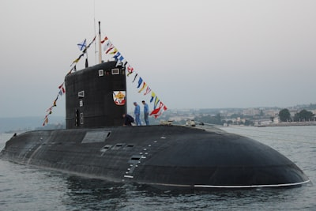

1. 1050 meters
2. -550 meters
3. -1050 meters
4. 550 meters

Question 16: A positive number multiplied by a positive number produces...



1. A positive number
2. A negative number
3. a positive or negative number, depending on the day of the week.
4. a positive or negative number, depending on which number is larger.

Question 17: Adding a negative number is the same as...



1. Adding a positive number
2. Subtracting a negative number
3. Multiplying by a negative number
4. Subtracting a positive number

Question 18: Evaluate (-7)(7).



1. (-49)
2. 49
3. (-14)
4. 0

Question 19: Evaluate (-30) ÷ (-5).



1. 6
2. (-6)
3. 8
4. 20

Question 20: Evaluate (-5) - (-5) + 4.



1. 14
2. (-4)
3. 4
4. (-5)

Question 21: Evaluate (-1) + 5 - (-3) - 2.



1. 11
2. (-11)
3. (-5)
4. 5

Question 22: Evaluate (-9) + 3.



1. 9
2. (-3)
3. 6
4. (-6)

Question 23: What integer represents 10 minutes before the start of a movie?



1. 1
2. 0
3. (-10)
4. 10

Question 24: What integer represents 5 minutes after a movie has ended?



1. 10
2. 5
3. (-5)
4. (-10)

Question 25: 4 - (-3) could also be written as...

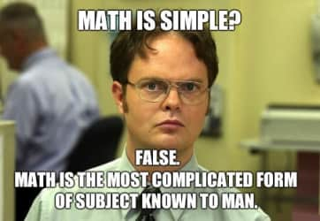

1. 4 – 3
2. 4 + 3
3. 4 x 3
4. 3 – 4

Question 26: (-3) + (-7) could also be written as...

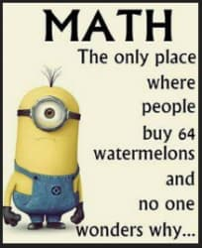

1. 3 – 7
2. (-3) + 7
3. (-3) – 7
4. 3 + 7

Question 27: Which of these produces (-27)?



1. (-33) + (-6)
2. (-24) + 3
3. 20 + (-7)
4. 9 x (-3)

Question 28: Which of these is the GREATEST?



1. (-20)
2. (-5)
3. 0
4. (-40)

Question 29: On a horizontal number line, all numbers to the right of zero are...



1. Positive
2. Negative
3. Neutral
4. Left

Question 30: Which of the following does not produce zero?



1. 5 + (-5)
2. 10 + (-10)
3. 1 + (-11)
4. (-9) + 9

Question 31: The result of (-2) - (-8) is...



1. -6
2. 6
3. -10
4. 10

Question 32: Red chips are positive, blue chips are negative. What sum do these chips represent?



1. 4
2. (-4)
3. (-2)
4. 6

Question 33: Red chips are positive, blue chips are negative. What sum do these chips represent?



1. 2
2. 6
3. 12
4. (-2)

Question 34: Debt, degrees below zero, and meters below sea level would be best described with...



1. A positive integer
2. A negative integer
3. Zero
4. Two negative integers multiplied together

Question 35: A paycheque, temperatures above freezing and meters above sea level would be best described with...



1. A positive integer
2. A negative integer
3. Zero
4. A negative integer multiplied by a positive integer

Question 36: What are two ways to model integer addition and subtraction?



1. A bar graph and a line graph
2. A number line and a probability tree
3. A number line and integer chips
4. Integer chips and potato chips

Question 37: Evaluate (-5)(3) + 2 - 4.



1. 17
2. (-17)
3. (-5)
4. (-10)

Question 38: Evaluate (-2)(-3)(-4).

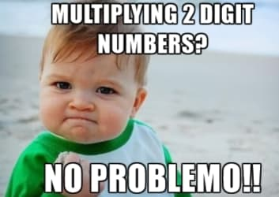

1. (-9)
2. 9
3. 24
4. (-24)

Question 39: Which of these is equivalent to (-4)² + 3?



1. (-19)
2. 19
3. (-13)
4. (-5)

Question 40: Evaluate (-12) ÷ 4 + (-3).

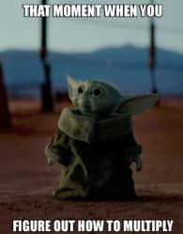

1. 6
2. (-6)
3. (-11)
4. (-16)

Question 41: Which addition statement best represents this number line?

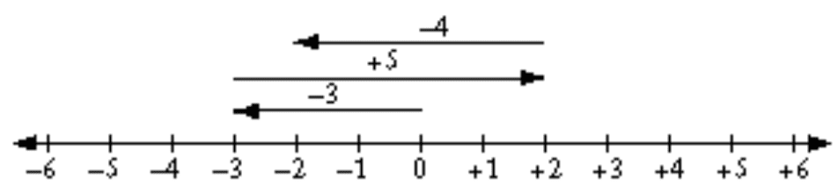

1. 4 + 5 + 3
2. 3 - 5 + 4
3. (-3) + 5 + (-4)
4. (-3) + (-5) + (-4)

Question 42: The opposite integer of 25 is...



1. 25
2. (-25)
3. 5
4. (-2)

Question 43: Evaluate (-120) - (-123).



1. 3
2. 243
3. (-3)
4. (-243)

Question 44: When we add the opposite to complete a subtraction question, we need to...

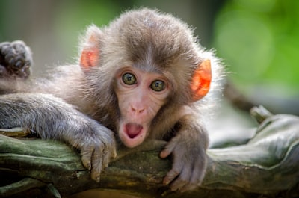

1. Change the number on the left
2. Change both numbers
3. Change the number on the right
4. Keep both numbers the same

Question 45: Evaluate 8 x (-5).

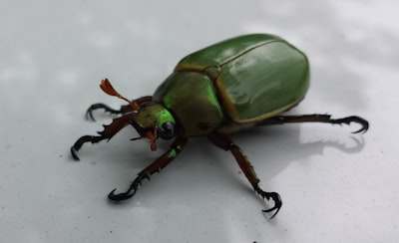

1. (-40)
2. 40
3. 45
4. (-45)

Question 46: Which addition statement best describes these integer chips?

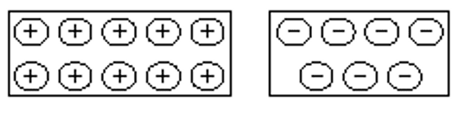

1. 10 + (-7)
2. (-10) + (-7)
3. (-10) + 7
4. 10 + 7

Question 47: Which addition statement best describes these chips?

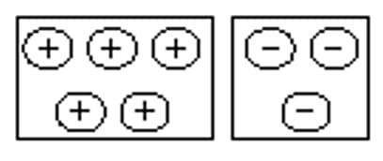

1. 5 + 3
2. (-5) + (-3)
3. 5 + (-3)
4. (-5) + 3

Question 48: Which of these temperatures is the coldest: (-1), 5, (-10), or 12?

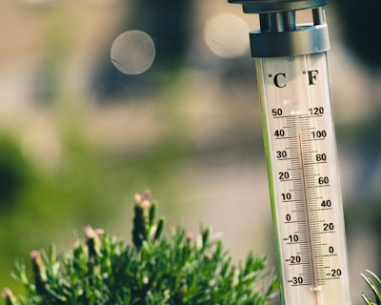

1. (-1)
2. 5
3. (-10)
4. 12

Question 49: Evaluate (-66) ÷ (-11).

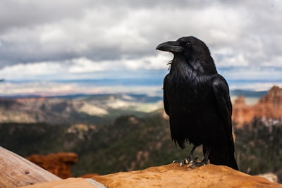

1. 11
2. (-6)
3. (-55)
4. 6

Question 50: Kelly jogged for 45 minutes and burned 400 calories. Afterwards, she ate two slices of pizza and gained 700 calories. How can this be best expressed as an addition question?



1. 45 + 400 + (-700)
2. 45 + (-400) + (-700)
3. (-400) + (-700)
4. (-400) + 700