[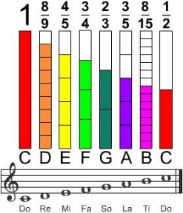](https://www.youtube.com/watch?v=YHlrb9KsyP4) [](https://www.youtube.com/watch?v=YHlrb9KsyP4)

**CREATE A FRACTION MODEL**

Watch the video of students playing the "[Don't Stop Believin'](https://www.youtube.com/watch?v=YHlrb9KsyP4)" by Journey.

Three players are wearing 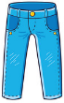 blue jeans.

1. What fraction of the group is this?

What if half of those wearing blue jeans didn’t show up?

1. What fraction of the full group would now be wearing jeans?
2. What % is this?

Create an area model to show ½ the musicians wearing blue jeans not showing up?

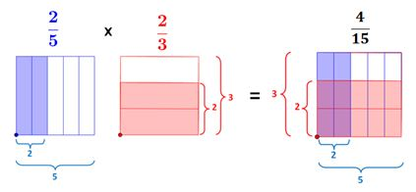

[C:\Users\C32476\AppData\Local\Microsoft\Windows\INetCache\Content.Word\fmama.png](https://teachablemath.com/apps/fraction-multiplication-area-model-app/) [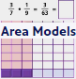](https://contrib.pbslearningmedia.org/WGBH/conv20/mgbh-int-fracmultmodel/index.html)

[Review w/ RUFFLE -.swf flash file.](http://www.downwindkennels.com/me/SubjectLinks/math/mathgames/areamodeltimesfrac.swf)

[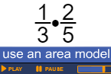](http://www.downwindkennels.com/school/me/SubjectLinks/math/mathgames/areamodeltimesfrac.swf)

ANSWER

3/8 = 0.375 x100 = 37.5%

3/8 x 1/2= 3/16

3/16= 0.1875 x 100 = 18.75%

Therefore, if ½ of those wearing blue jeans didn’t show up, that would be 3/16 or only 18.75% of the 8 person group would now be wearing blue jeans.