**Circle Parts 2.0 Kahoot**



1. How many **centers** does a circle have?





1. A circle **can’t** have more than one radii.

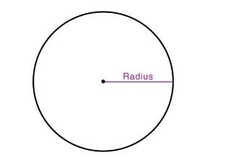



1. What is the **radius**?

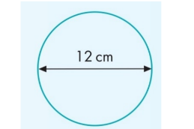

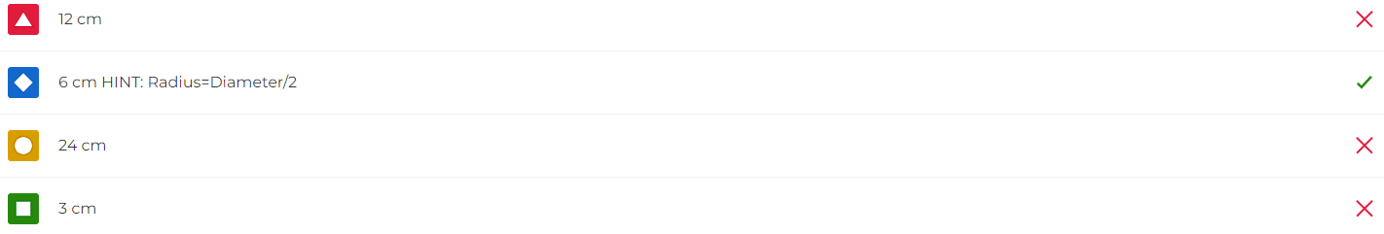

1. The formula for the **radius** is r = 2d.

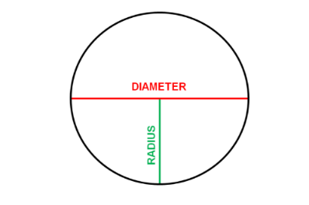



1. A diameter is a ‘special’ chord.

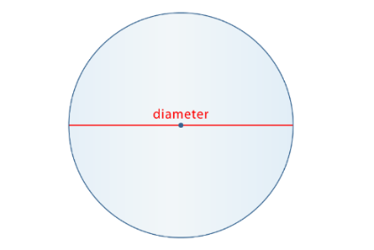



1. What is the **diameter**?

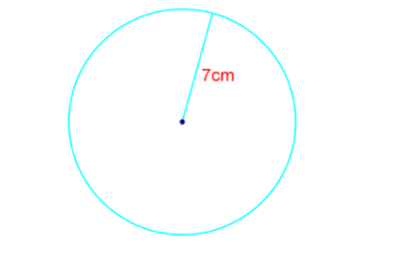

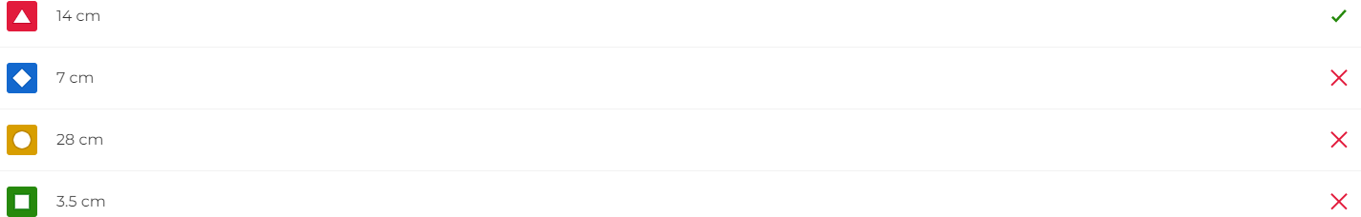

1. The formula for the **diameter** is d = r/2.





1. A circle can have **two radii** of different lengths.

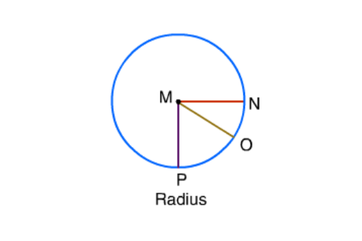



1. The diameter does **NOT** have to go through a circle’s center (the origin).

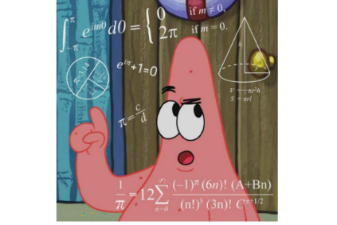



1. What is the formula for the **diameter**?

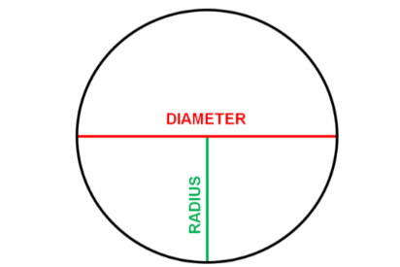

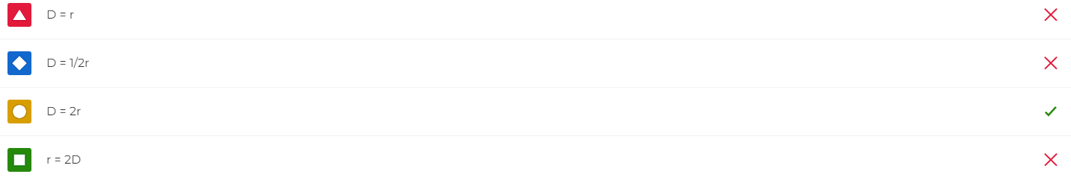

1. The distance between A and B is called…

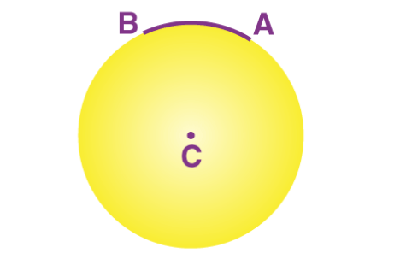

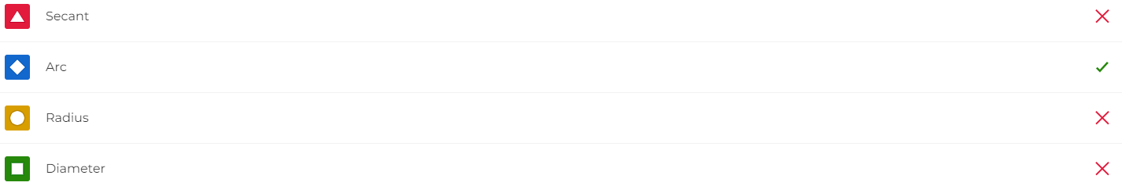

1. What is the **shaded area** called?

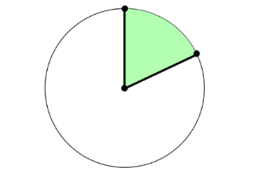



1. A line that passes through 2 points on a circle and continues is called a…

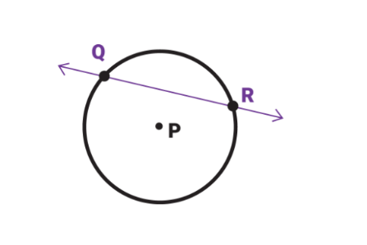

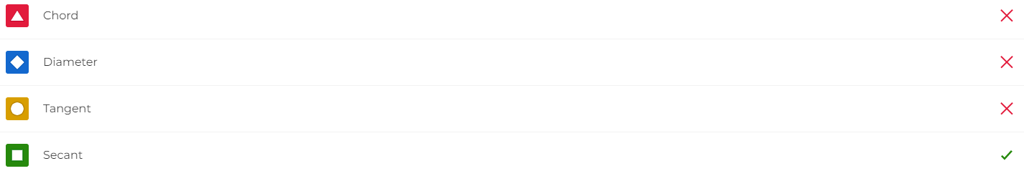

1. What is the **longest chord** in a circle called?



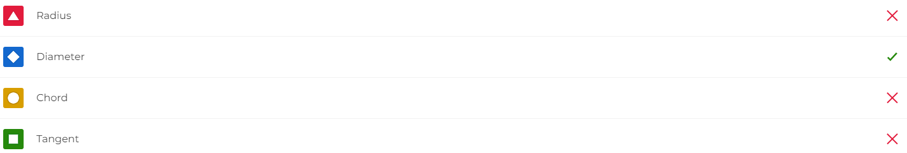

1. What is the **shaded region** called?

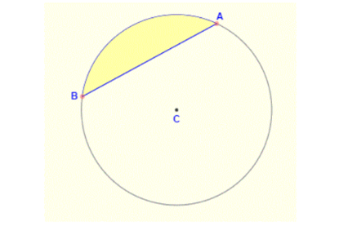

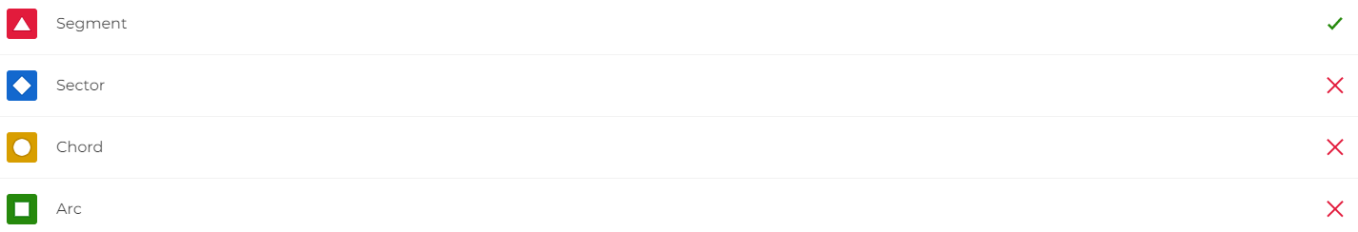

1. **The tangent line** intersects a circle at 2 different points.





1. Which of the lines is a **secant line**?

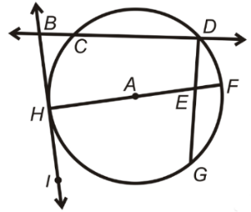



1. The straight line segment that joins any 2 points on a circle is called a…



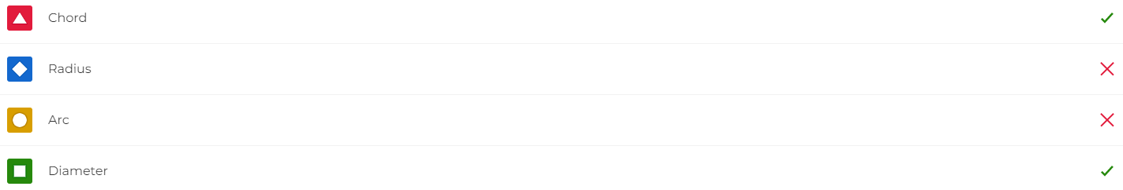

1. Which of the following lines is **a tangent line**?

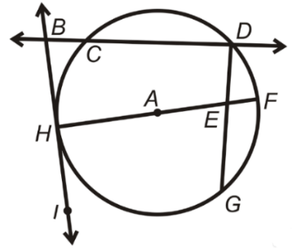



1. Why is this line **NOT** a **diameter**?

