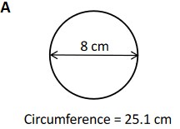 **C=πd 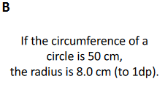 r= $\frac{C}{2π}$**

**=3.14x8cm = $\frac{50cm}{2 ×3.14}$**

**=25.1cm =8.0cm**

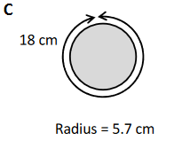

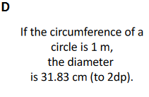 **r= $\frac{C}{2π}$** **d= $\frac{C}{π}$**

**= $\frac{18cm}{2 ×3.14}$ = $\frac{1m}{3.14}$**

**=2.9cm =31.83cm**

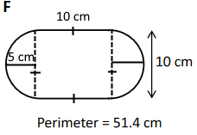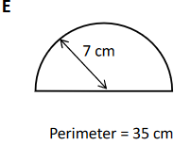 **P=0.5C+d** **P=C+s+s**

**=0.5(2πr)+(2r) =2πr+10cm+10cm**

**=(πr)+(2r) =(2x3.14x5cm)+20cm**

**=(3.14x7cm)+(2x7cm) =31.4cm+20cm**

**=36cm =51.4cm**

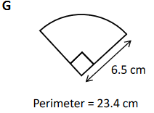 **P=0.25C+2r 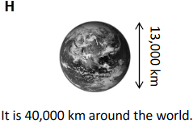 C=πd**

**=0.25(2πr)+2r =3.14x13 000km**

**=(0.5πr)+2r =40 820km**

**=(0.5x3.14x6.5cm)+(2x6.5cm)**

**=10.2cm+13cm**

**=23.2cm**

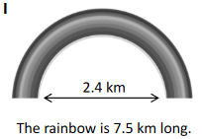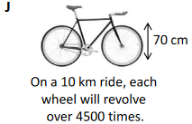 **L=0.5C C=πd**

**=0.5(πd) =3.14x70cm**

**=0.5x3.14x2.4km =220cm x $\frac{1km}{100000cm}$**

**=3.8km =0.0022km**

**Rotations = Distance $÷$ C or Distance = Cx4500**

**= 10km $÷$ 0.0022km = 0.0022kmx4500**

**= 4545 = 9.9 km**

**⸫ 4545 revolutions are needed to go 10km. A wheel with this diameter would travel only 9.9 km with 4500 revolutions.**

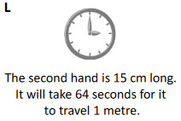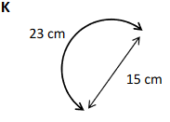 **P=0.5C C=2πr**

**=0.5(πd) =2x3.14x15cm**

**=0.5(3.14x15cm) =94.2cm**

**=23.6cm Distance each second = 94.2cm $÷$ 60s**

**= 1.57cm/s**

**Distance in 64s = 1.57cm/s x 64s**  **= 1m**

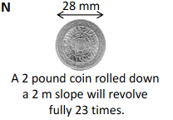**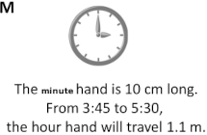 C=2πr**

**=2x3.14x10cm C=πd**

**=62.8cm =3.14x28mm**

**=87.96mm x $\frac{1m}{1000mm}$**

**From 3:45 to 5:30, the minute hand makes 1.75 rotations =0.08796m**

**Distance = C x 1.75 Rotations = Distance $÷$ C**

**= 62.8cm x 1.75 = 2m $÷$ 0.08796m**

**= 110cm x $\frac{1m}{100cm}$ = 22.73 (not a full 23)**

**= 1.1m**

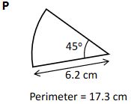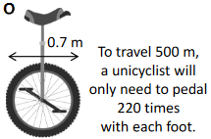

**C=πd** **There are 360° in a**

**=3.14x0.7m circle. This sector has**

**=2.2m an angle of 45°.**

**Therefore, it is $\frac{45°}{360°}$ = $\frac{1}{8}$ of a circle.**

**The unicycle gets 1 full rotation each time both feet pedal P= $\frac{1}{8}$ C+s+s**

**Distance = C x Rotations = $\frac{1}{8}$ (2πr)+s+s**

**= 2.2m x 220 = $\frac{1}{8}$ (2x3.14x6.2cm)+6.2cm+6.2cm**

**= 484m = $\frac{1}{8}$ (38.9cm)+12.4cm**

**=0.125(38.9cm)+12.4cm**

**= 4.9cm+12.4cm**

**= 17.3cm**