 Fencing Problem – Using Perimeter

There are 70.8m of fencing around a rectangular field.

The length of the field is 20.4m.

**What is the width of the field?**

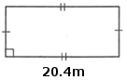

P = 2l+2w

70.8m = 2(20.4m) + 2w

70.8m = 40.8m +2w

70.8m – 40.8m = 40.8m + 2w – 40.8m

30.0m = 2w

30.0m/2 = 2w/2

15m = w

**∴** The width of the field is 15m.