**Calculating Sales** 

1. 25% off of $300
2. 50% off of $19.99

1. $10 off of $59.99 4. 30% off of $99.99

5. 40% off of $699.49 6. 10% off of $9.99

7. 25% off of $850.49

8. 60% off of $67.45



9. 10% off of $119.99 10. $30 off of $199.99



11. 45% off of $1999.99 12. 15% off of $94.99

**ANSWERS**

1. **25% off of $300**

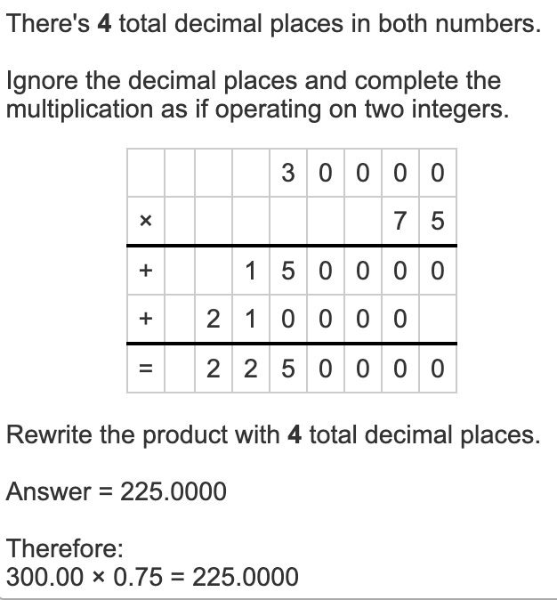

**2. 50% off of $19.99**

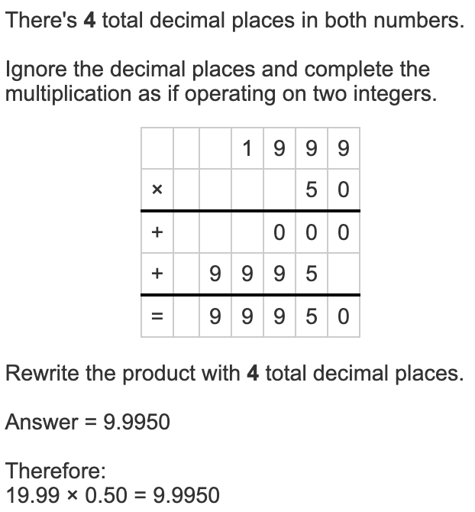

**3. $10 off of $59.99**

$59.99 - $10 = $49.99

**4. 30% off of $99.99**

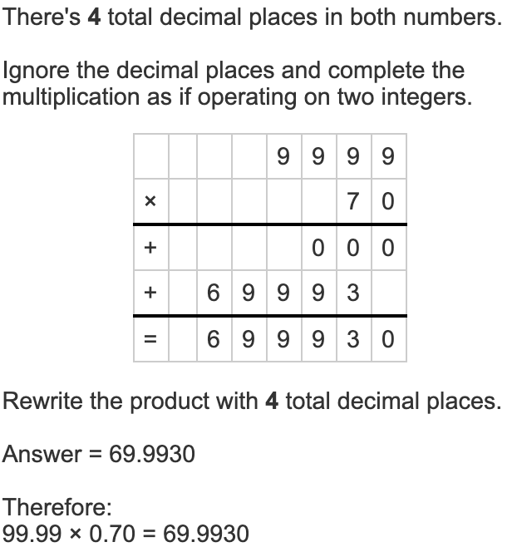

**5. 40% off of $699.49**

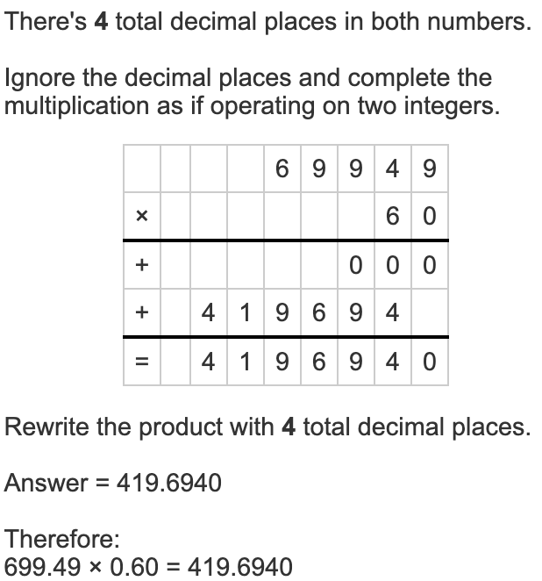

**6. 10% off of $9.99**

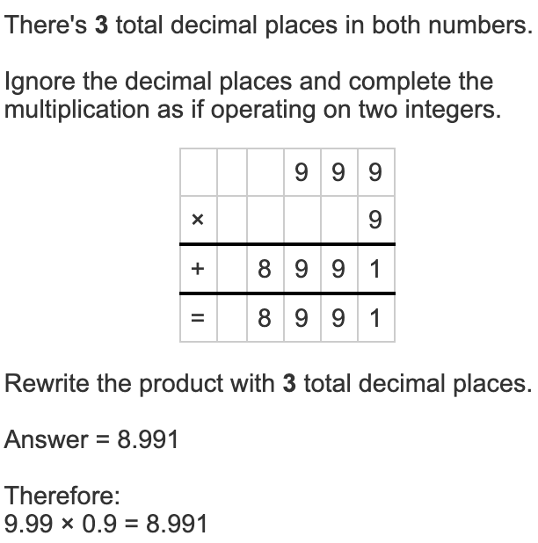

**7. 25% off of $850.49**

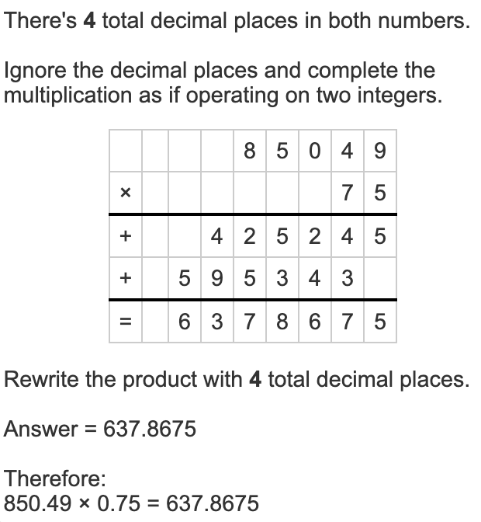

**8. 60% off of $67.45**

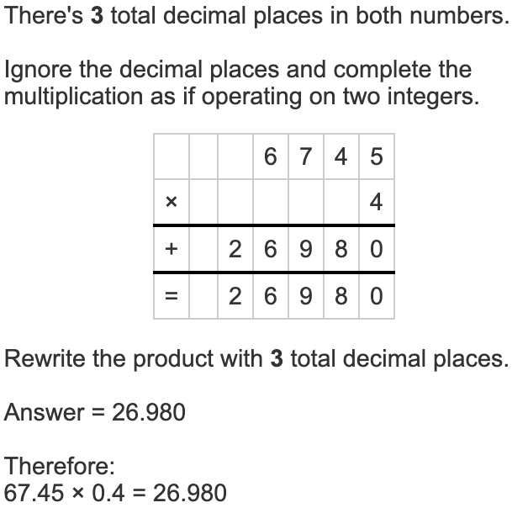

**9. 10% off of $119.99**

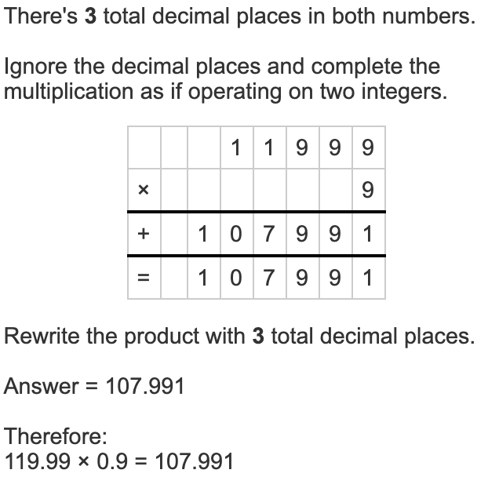

**10. $30 off of $199.99**

$199.99 - $30 = $169.99

**11. 45% off of $1999.99**

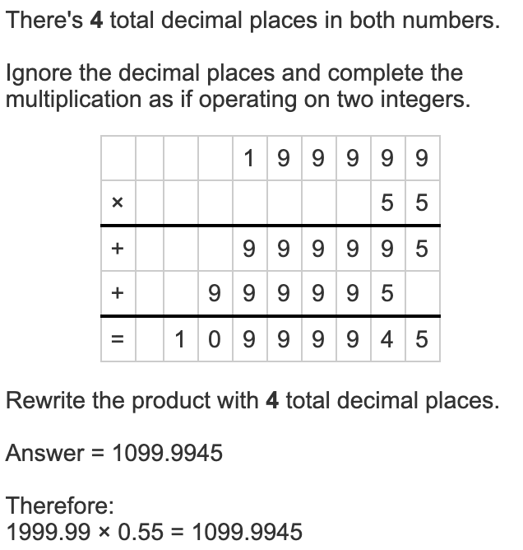

**12. 15% off of $94.99**

