**Currency**

Top 10 Traded Global Currencies

|  |  |
| --- | --- |
| **Canadian Dollar** | **1.00 CAD** |
| US Dollar | 0.79 |
| Euro | 0.65 |
| British Pound | 0.57 |
| Indian Rupee | 57.48 |
| Australian Dollar | 1.02 |
| Singapore Dollar | 1.05 |
| Swiss Franc | 0.71 |
| Malaysian Ringgit | 3.19 |
| Japanese Yen | 83.37 |
| Chinese Yuan | 5.11 |

1. How much is $300 CAD in Australian Dollars?
2. How much is $5000 CAD in Indian Rupees?
3. How much is $40 CAD in Singapore Dollars?
4. I have exchanged 75 Canadian Dollars for some Euros, how many Euros do I have?
5. 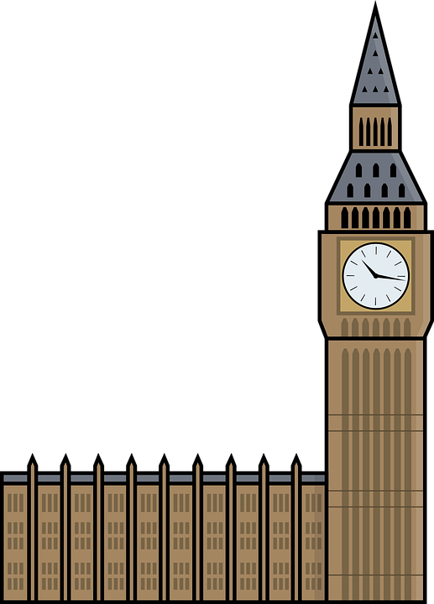You are on vacation in England and you see an XBox Series X being sold for 370 Pounds. Back in Canada the same console is $600, is it a good idea to buy it here in England?
6. How much would a $2.99 CAD Kit Kat bar cost in Indian Rupees?
7. Which of the currencies listed is the strongest? How can you tell?
8. How many Rupees is $45 CAD?

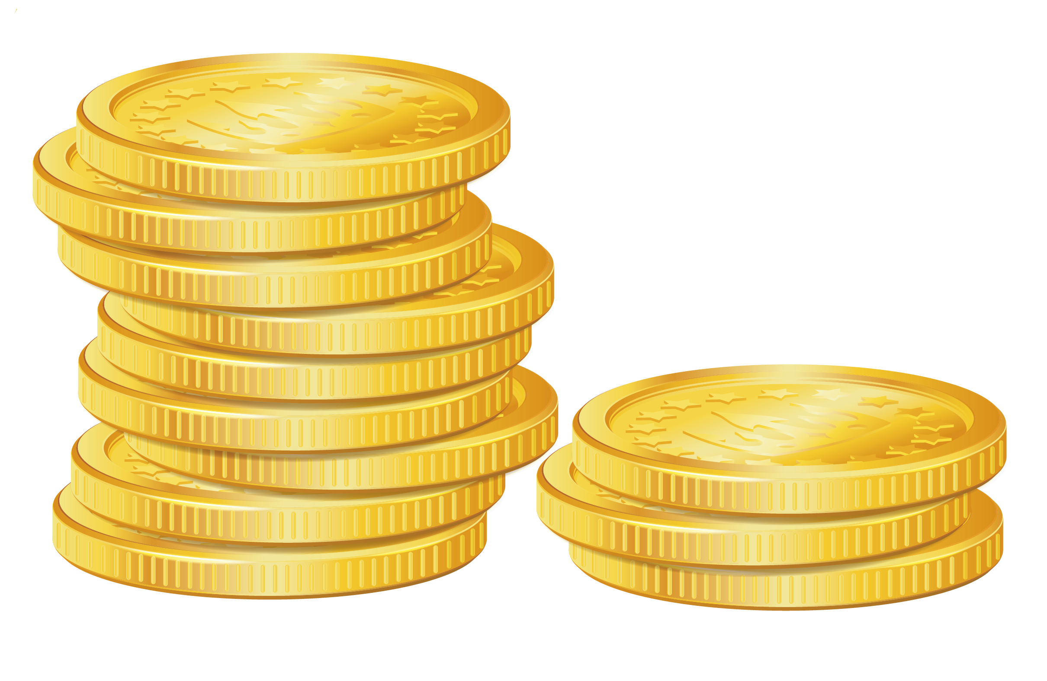

1. How many Francs is 40 Malaysian Ringgits? How does that compare to The Yuan?
2. You are travelling to Barcelona and will need Euros for your trip. You can not get them ahead of time at your local bank branch, what other options do you have?
3. You have just arrived in a new country and realize you have no way to spend money as this country uses a different currency, how can you get some of the local currency?
4. You are leaving for Mexico in a week, how will you get your Pesos before leaving for your trip?



13. You are going on a trip to Whitehorse, Yukon, how will you make sure you have the proper currency for your trip?

**Currency**

Top 10 Traded Global Currencies

|  |  |
| --- | --- |
| **Canadian Dollar** | **1.00 CAD** |
| US Dollar | 0.79 |
| Euro | 0.65 |
| British Pound | 0.57 |
| Indian Rupee | 57.48 |
| Australian Dollar | 1.02 |
| Singapore Dollar | 1.05 |
| Swiss Franc | 0.71 |
| Malaysian Ringgit | 3.19 |
| Japanese Yen | 83.37 |
| Chinese Yuan | 5.11 |

1. How much is $300 CAD in Australian Dollars?

**$300 times the exchange rate of 1.02**

**$300 x 1.02 = $306 AUD**

1. How much is $5000 CAD in Indian Rupees?

**$5000 times the exchange rate of 57.48**

**$5000 x 57.48 = ₹287400 Rupees**

1. How much is $40 CAD in Singapore Dollars?

**$40 times the exchange rate of 1.05**

**$40 x 1.05 = $42 SG$**



1. I have exchanged 75 Canadian Dollars for some Euros, how many Euros do I have?

**$75 times the exchange rate of 0.65**

**$75 x 0.65 = €48.75 Euros**

1. You are on vacation in England and you see an XBox Series X being sold for 370 Pounds. Back in Canada the same console is $600, is it a good idea to buy it here in England?

**Let’s find out how much the “Canadian console” would cost if bought in England**

**$600 times the exchange rate of 0.57**

**$600 x 0.57 = £342.00 Pounds**

**You should buy the Xbox back in Canada.**



1. How much would a $2.99 CAD Kit Kat bar cost in Indian Rupees?

**$2.99 times the exchange rate of 57.48**

**$2.99 x 57.48 = ₹171.87 Rupees**

1. Which of the currencies listed is the strongest? How can you tell?

**The Pound is the strongest currency listed. You can tell because it has the lowest exchange rate (converting to Pounds from CAD will give you the smallest amount of the foreign currency because it is worth so much more)**

1. How many Rupees is $45 cad?

**$45.00 times the exchange rate of 57.48**

**$45.00 x 57.48 = ₹2586.60 Rupees**

1. How many Francs is 40 Malaysian Ringgits? How does that compare to The Yuan?



**40 MYR in CAD is 40 ÷ 3.19.**

**40 MYR ÷ 3.19 = $12.54**

**Now to turn that into Francs**

**$12.54 times the exchange rate of 0.71**

**$12.54 x 0.71 = FR8.90 Francs**

**40 Malaysian Ringgits is 8.90 Swiss Francs**

**For the Yuan:**

**$12.54 times the exchange rate of 5.11**

**$12.54 x 5.11 = ¥64.08 Yuan**

**The Frank is a stronger currency than the Yuan**

1. You are travelling to Barcelona and will need Euros for your trip. You cannot get them ahead of time at your local bank branch, what other options do you have?

**You could go to a Currency Exchange Firm before you leave or at your destination, you could go to an affiliate bank at your destination or you could go to an ATM at your destination.**

1. You have just arrived in a new country and realize you have no way to spend money as this country uses a different currency, how can you get some of the local currency?

**You could go to a Currency Exchange Firm, you could go to an affiliate bank at your destination or you could go to an ATM at your location.**

1. You are leaving for Mexico in a week, how will you get your Pesos before leaving for your trip?

**You should go to your local bank branch and order the pesos ahead of time.**

13. You are going on a trip to Whitehorse Yukon, how will you make sure you have the proper currency for your trip?

**The Yukon uses the Canadian dollar so you will not need to trade in your money.**