**Calculating Sales Taxes**

1. Alia is baking a cake at home and she realizes that she doesn't have enough milk. She will need to run out to the store and buy some. A carton of milk costs $4.49 plus tax, how much money will she need to bring to the store?
2. Charlie is saving up his money to buy a Nintendo Switch. The Nintendo Switch costs $299.99 plus tax. How much will Charlie need to save?
3. Sarah has a grocery list that includes milk ($4.49 plus tax), cheese ($8.29 plus tax), bread ($3.49 plus tax) and apple juice ($3.29 plus tax). If she only needs to buy one of each item, how much will this all cost?
4. Jake is out for dinner in Saskatchewan, where the sales tax is 11%. He ordered a cheeseburger ($14.99 plus tax) and an Ice Tea ($2.99 plus tax), how much will his meal cost?
5. Thanh would like to buy a new desk chair, it costs $159.99 plus tax. How much will Thanh have to pay?
6. How much money will Salma need to save for a new bike if it costs 499.99 plus tax?

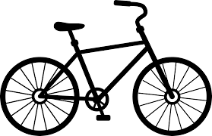

1. Li is shopping for skis in Alberta where the sales tax is 5%. The skis cost $749.00 plus tax and the poles cost $99.99 plus tax. How much will this all cost in the end?

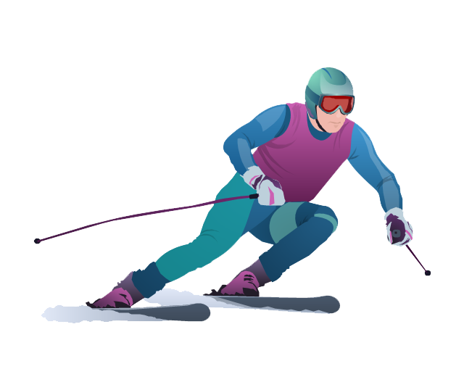

1. Abdul wants to buy a new painting set. His new brushes will cost $99.08 plus tax, new paints will cost $74.99 plus tax, and a new canvas will cost $84.47 plus tax, how much will it all cost in the end?
2. Inez will need to buy her dog some new dog food, a bag costs $47.99 plus tax. If Inez has $60, can she also buy her dog a new toy for $4.99 plus tax?
3. Roberto is saving up $20 a week to buy a new computer for $550.00 plus tax. How long will he have to save?
4. Iga has $10, a chocolate chip cookie costs $3.00 plus tax. How many cookies can she buy?



1. Lucia is replacing her kayak. She lives in Lake Louise, Alberta (sales tax is 5%). The store in her town sells the kayak she wants for $599.99 plus tax. In Field, British Columbia (sales tax is 12%) a store sells the kayak for $569.99. Where should she buy her kayak?

**Calculating Sales Taxes**

1. Alia is baking a cake at home and she realizes that she doesn't have enough milk. She will need to run out to the store and buy some. A carton of milk costs $4.49 plus tax, how much money will she need to bring to the store?

The sales tax in Ontario is 13% so we need to multiply $4.49 by 1.13:

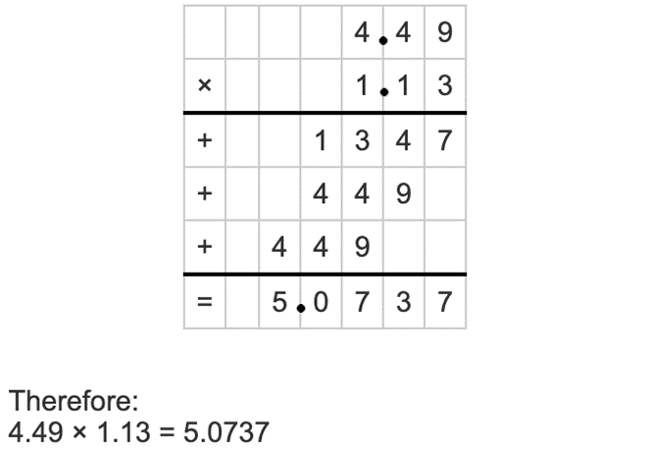

**∴** The total price will be $5.07.

1. Charlie is saving up his money to buy a Nintendo Switch. The Nintendo Switch costs $299.99 plus tax, how much will Charlie need to save?

The sales tax in Ontario is 13% so we need to multiply $299.99 by 1.13:

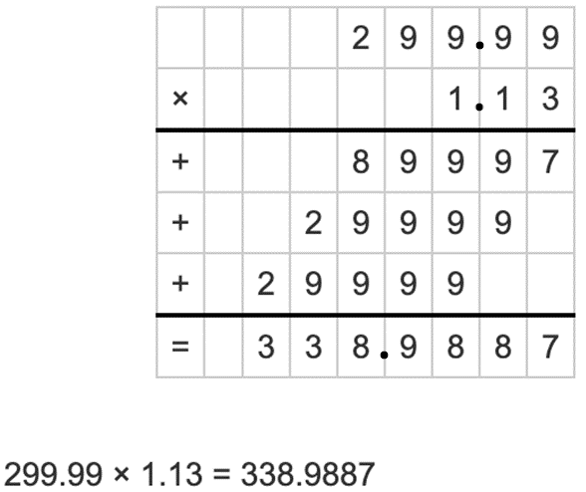

**∴** Charlie will need to save $338.99.

1. Sarah has a grocery list that includes milk ($4.49 plus tax), cheese ($8.29 plus tax), bread ($3.49 plus tax) & apple juice ($3.29 plus tax). How much will this all cost?

The sales tax in Ontario is 13% so we need to multiply the total of all of these groceries by 1.13:

$4.49+$8.29+$3.49+$3.29 = $19.56

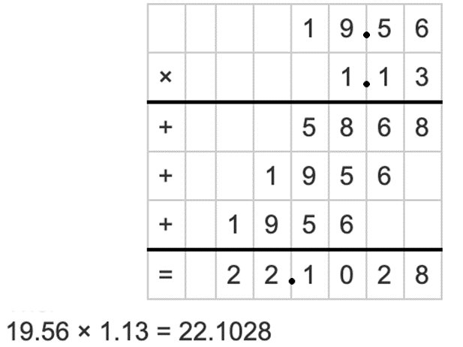

**∴** The groceries will cost Sarah $22.10

1. Jake is out for dinner in Saskatchewan. (Sales tax is 11%). He ordered a cheeseburger ($14.99 plus tax) & an Ice Tea ($2.99 plus tax), how much will this cost?

The sales tax in Saskatchewan is 11% so we need to multiply the total of these two items by 1.11: $14.99 + $2.99 = $17.98

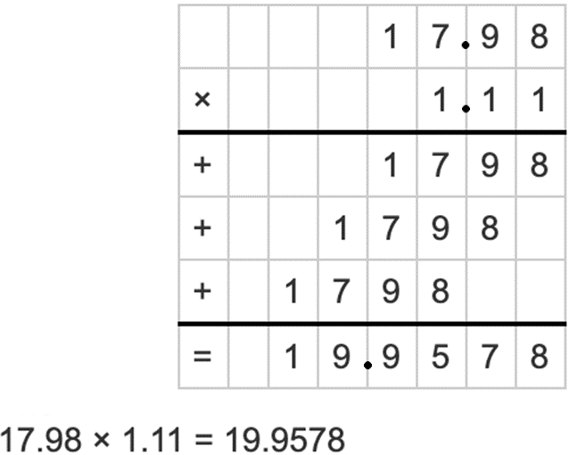

**∴**Jake’s meal will cost him $19.96

1. Thanh would like to buy a new desk chair, it costs $159.99 plus tax. How much will Thanh have to pay?

The sales tax in Ontario is 13% so we need to multiply $159.99 by 1.13:

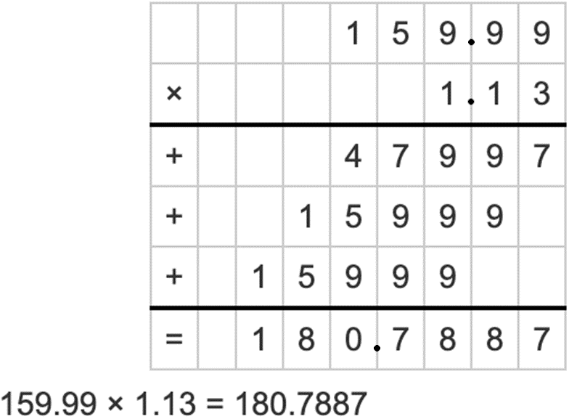

**∴** Thanh’s new desk chair will cost him $180.79

1. How much money will Salma need to save for a new bike if it costs 499.99 plus tax?

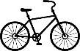

The sales tax in Ontario is 13% so we need to multiply $499.99 by 1.13:

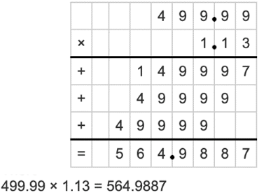

**∴** Salma will have to save $564.99

1. Li is shopping for skis in Alberta (sales tax is 5%). The skis cost $749.00 plus tax. The poles cost $99.99 plus tax. How much will this all cost in the end?

The sales tax in Alberta is 5% so we need to multiply the total of these two items by 1.05: $749.00 + $99.99 = $848.99

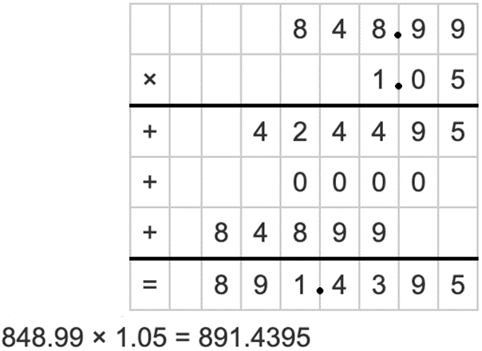

**∴** The skis & poles will cost Li $891.44

1. Abdul wants to buy a new painting set. His new brushes will cost $99.08 plus tax, new paints will cost $74.99 plus tax & a new canvas will cost $84.47 plus tax. How much will it all cost?

The sales tax in Ontario is 13% so we need to multiply the total by 1.13:

$99.08 + $74.99 + $84.47 = $258.54

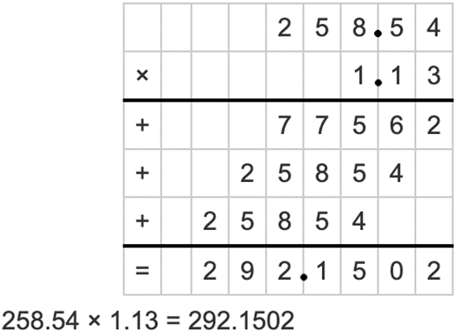

**∴** Abdul’s new painting set will cost him $292.15

1. Inez will need to buy her dog some new dog food, a bag costs $47.99 plus tax. If Inez has $60, can she also buy her dog a new toy for $4.99?

The sales tax in Ontario is 13% so we need to multiply the total by 1.13:

$47.99+$4.99 = $52.98

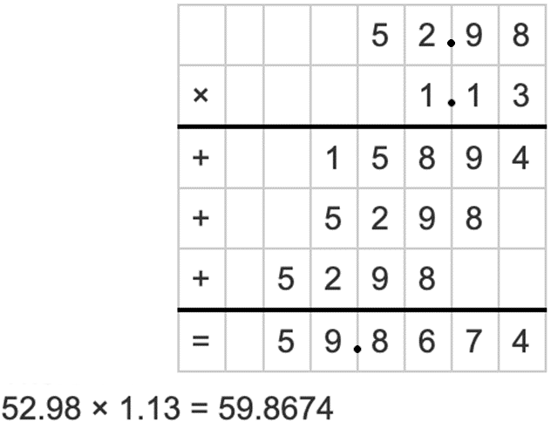

**∴** Inez will be able to buy her dog a new toy.

1. Roberto is saving up $20 a week to buy a new computer for $550.00 plus tax. How long will he have to save?

The sales tax in Ontario is 13% so we need to multiply $550.00 by 1.13:

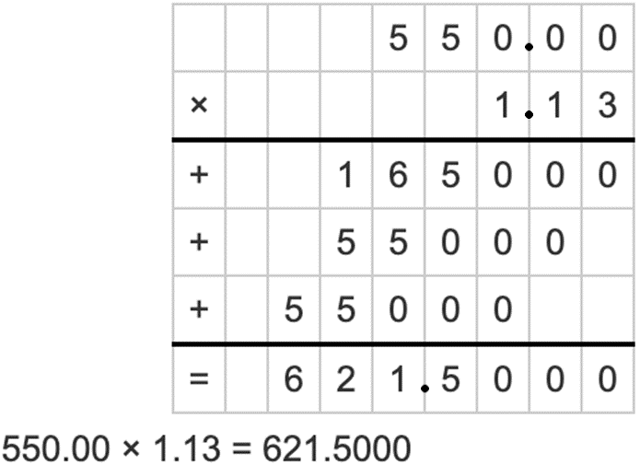

The total will come to $621.50. $621.50/$20 = 31.075

**∴** Roberto will need to put aside $20 a week for 32 weeks to buy the computer.

1. Iga has $10, a chocolate chip cookie costs $3.00 plus tax. How many cookies can she buy?

The sales tax in Ontario is 13% so we need to multiply the total price by 1.13:

The price of 1 cookie:

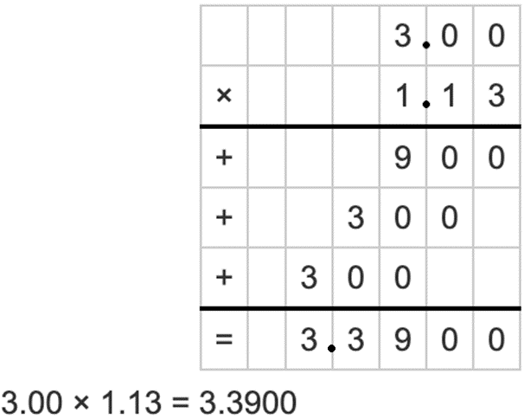

**∴** Iga can afford 1 cookie.

What about 2?

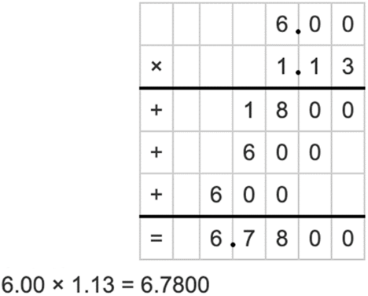

**∴** Iga can afford 2 cookies.

What about 3?

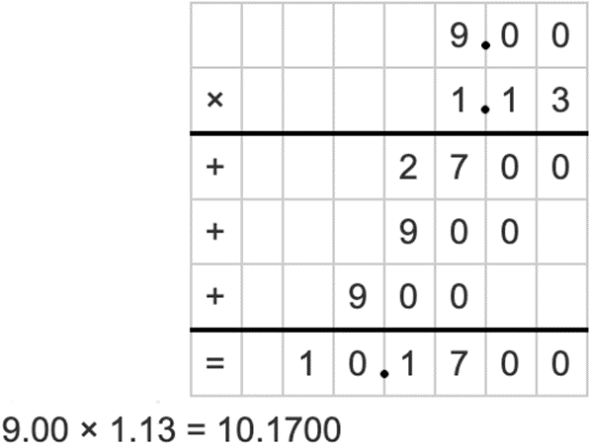

**∴** Iga can’t afford 3 cookies.

1. Lucia is replacing her kayak. She lives in Lake Louise, Alberta (sales tax is 5%). The store in her town sells the kayak she wants for $599.99 plus tax but in Field, British Columbia (sales tax is 12%) a store sells the kayak for $569.99, where should she buy her kayak?

We should calculate the total price for both Kayaks in order to make a decision.

The sales tax in Alberta is 5% so we need to multiply $599.99 by 1.13:

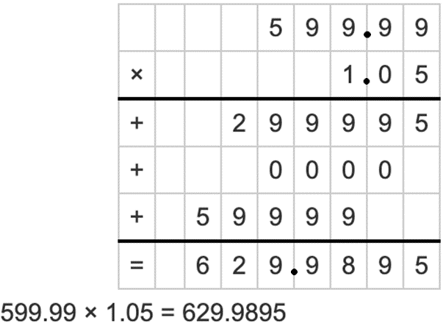

The sales tax in B.C. is 12%. We need to multiply $569.99 by 1.12:

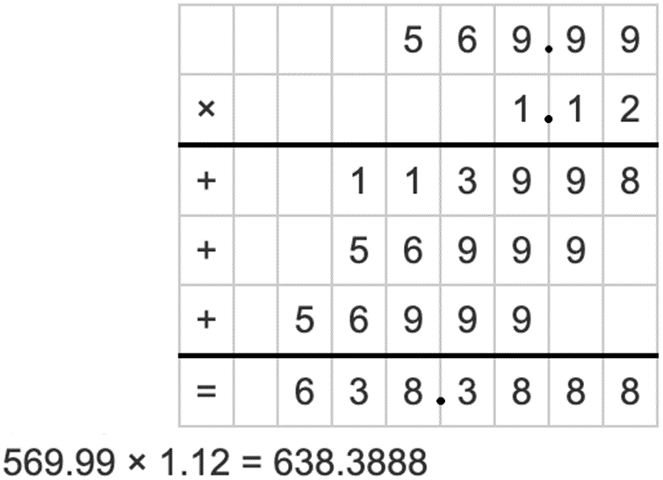

**∴** Comparing the 2 prices, Lucia should buy her kayak in Lake Louise.