 Algebra & Chess!  - ANSWERS!

FIND THE VALUE OF EACH VARIABLE.
Example: q + 2 = 11
q + 2 – 2 = 11 – 2
q = 9

- q + 6 = 15  q + 6 – 6 = 15 – 6  q = 9 | - 2q = 18  2q / 2 = 18 / 2  q = 9
- 3r = 15  3r / 3 = 15 / 3  r = 5 | - q – 5 = 4  q – 5 + 5 = 4 + 5  q = 9
- 4k – 5 = 7  4k - 5 + 5 = 7 + 5  4k = 12  4k / 4 = 12 / 4  k = 3 | - b + b + b + b + b = 15  5b =15  5b / 5 = 15 / 5  b = 3

 POINT SYSTEM 
Queen - 9 points
Rook - 5 points
Bishop - 3 points
Knight - 3 points
Pawn - 1 point
King - Priceless! / 0

SUBSTITUTION: Place the value of the variable into the expression & solve.
Example: 4r
= 4(5)
= 20

- 3p  = 3(1)  = 3 | - 2 + 5b  = 2 + 5(3)  = 17
- 3 / q  =3 / (9)  = 0.3333… | - 4k + 5  = 4 (3) + 5  = 17
- 2p + 3  = 2(1) + 3  = 5 | - 10p + 3  = 10(1) + 3  = 13

 MODEL EACH VARIABLE EXPRESSION. (Sketch it.)
Example: 4p is + + +

- 2r = +

- q + p + p = + +

- q – 2p = - +


How many points are your pieces worth at the start? Use an algebraic expression to solve.

8p + 2r + 2k+ 2b + q + z
= 8(1) + 2(5) + 2(3) + 2(3) + (9) + 0
= 8 + 10 + 6 + 6 + 9 + 0
= 39

⸫ the value of all my pieces on a chess board is 39 points.

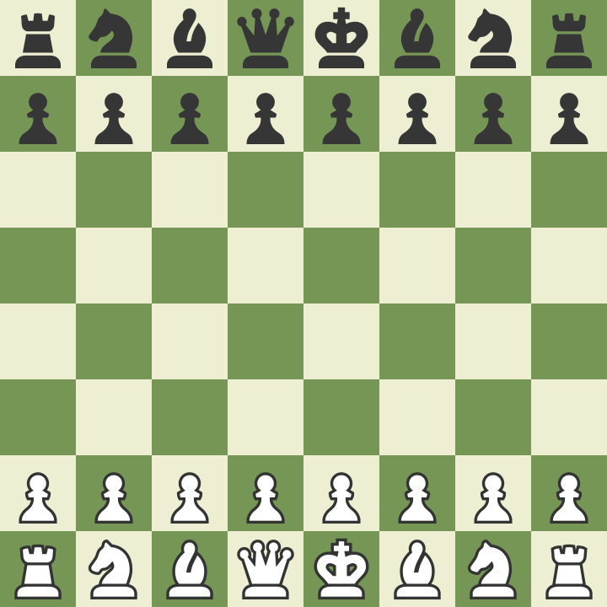

http://www.downwindkennels.com/me/Misc/chess/chess.html

