 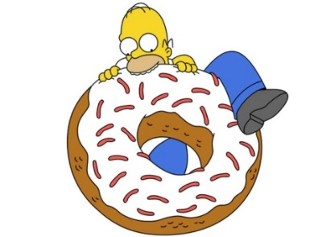

Homer bought two dozen doughnuts at Tim Horton’s. Bart, Lisa and Maggie each eat a couple. Dad eats five! Marge wasn’t home. How many doughnuts remain for the Simpsons?

* **HINT:** Create a variable expression! (-not an equation.)
* **DOUBLE HINT:** A B_ _ _ _ ’_ D _ _ _ N

**# bought – (# of kids x # of donuts eaten per kid) - # eaten by Homer =Remaining Donuts**

**a = # bought**

**b= # of kids**

**c= # of donuts eaten per child**

**d= #of donuts eaten by Homer**

**a-bc-d**

= 24 – 3(2) – 5

= 24 – 6 – 5

=18 – 5

=13

∴ 13 donuts remain. **– D’oh!**