Mr. F eats a hotdog for breakfast each morning.

At lunch Mr. F eats twice the number of hotdogs as Owen at lunch.

**Owen** ate _______ hotdogs today.

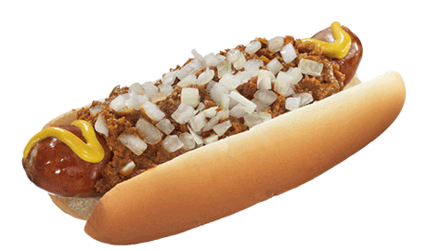

**How many did *Biker Dave* eat today?**

2x+1 Sun 0 1

**Owen Mr. F **

2x+1 Mon 1 3

2x+1 Tues 2 5

2x+1 Wed 3 7

2x+1 Thurs 4 9

2x+1 Fri 5 11

$\frac{n-1}{2}$ Sat 6 13