Transum Answer Key - Level Four

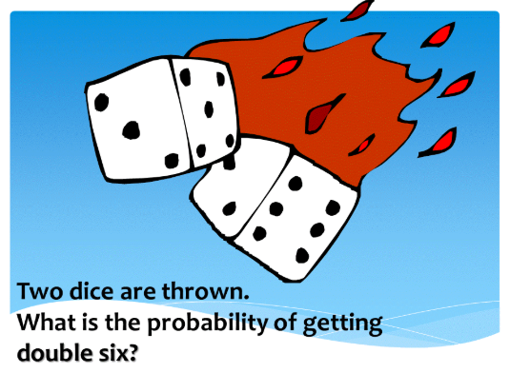
⅙ x ⅙ = 1/36

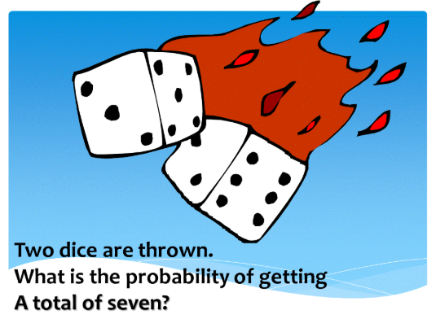
There are six possible ways to get seven with two dice and thirty-six possible overall combinations.
6/36 = 1/6

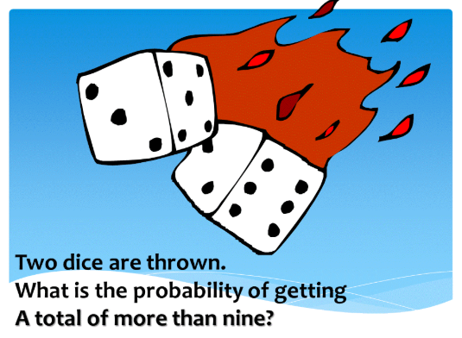
There are six ways to get a total greater than nine with two dice with thirty-six overall combinations. 6/36
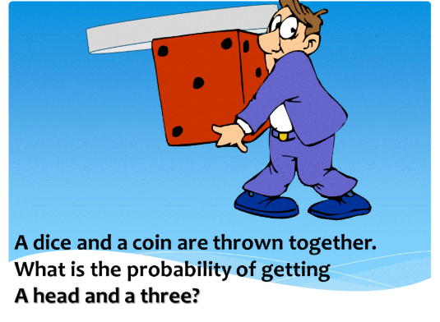
Odds of getting a head with one flip is ½.
Odds of getting a three with one roll is ⅙.
½ x ⅙ = 1/12

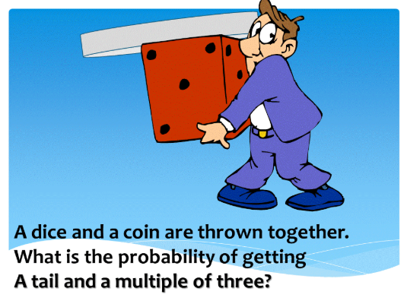
The probability of getting a tail with one coin flip is ½.
The probability of getting a multiple of three on a coin flip is 2/6 -> ⅓. This is because three and six are both multiples of three.
½ x ⅓ = ⅙

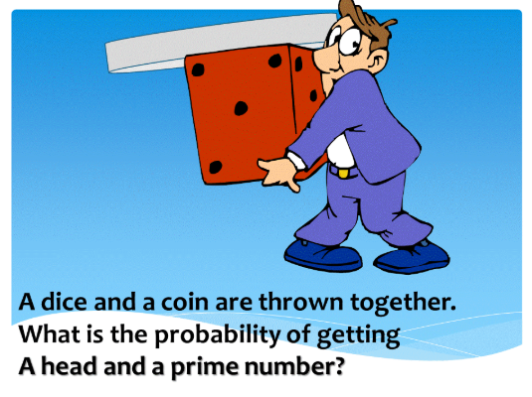
The probability of getting a head with one coin flip is ½.
Prime numbers are those that are only evenly divisible by one & itself.
1 IS NOT A PRIME NUMBER due to it not having two distinct factors.
A standard die has three prime numbers. Two, Three, Five
3/6 = ½
½ x ½ = ¼

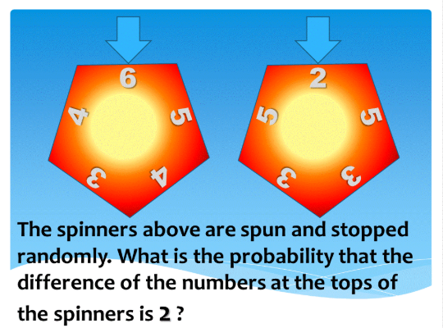
Difference is essentially subtraction.
The difference between six and two is four. The difference between five and five is zero, etc…
There are 5 numbers on each spinner = Total of 25 possible combinations.
There are six possible combinations that result in a difference of two at the top.
5&3, 5&3, 4&2, 3&5, 4&5, 4&2
6/25
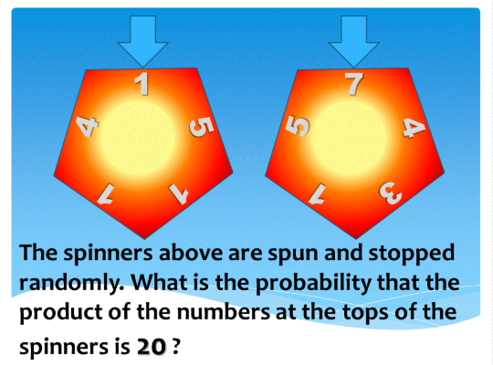
Product means multiplication.
The product of seven and one is seven. Continue this for every combination, find out which equals twenty.
5x4, 4x5
2/25

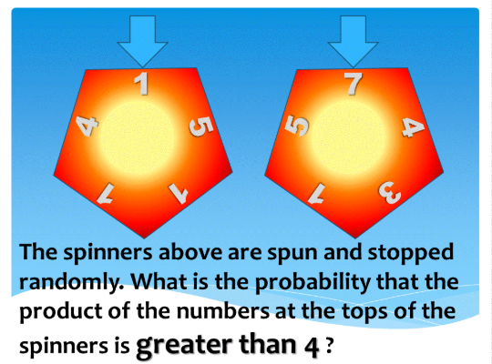
Now that we know the term product, we must find out how many combinations are greater than (bigger number than) four.
1x7, 1x5, 5x7, 5x4, 5x3, 5x1, 5x5, 1x5, 1x7, 1x5, 1x7,
4x7, 4x4, 4x3, 4x5
Fifteen combinations are greater than four.
15/25 = ⅗

Question: Three ordinary dice are rolled and their numbers multiplied together. What is the probability that this product is less than 216?

Answer: Find out how many possible combinations there are.
6x6x6 = 216
There is only one way to make two hundred sixteen as it requires the highest roll on each die. Therefore, every other combination is less than two hundred sixteen.
215/216

